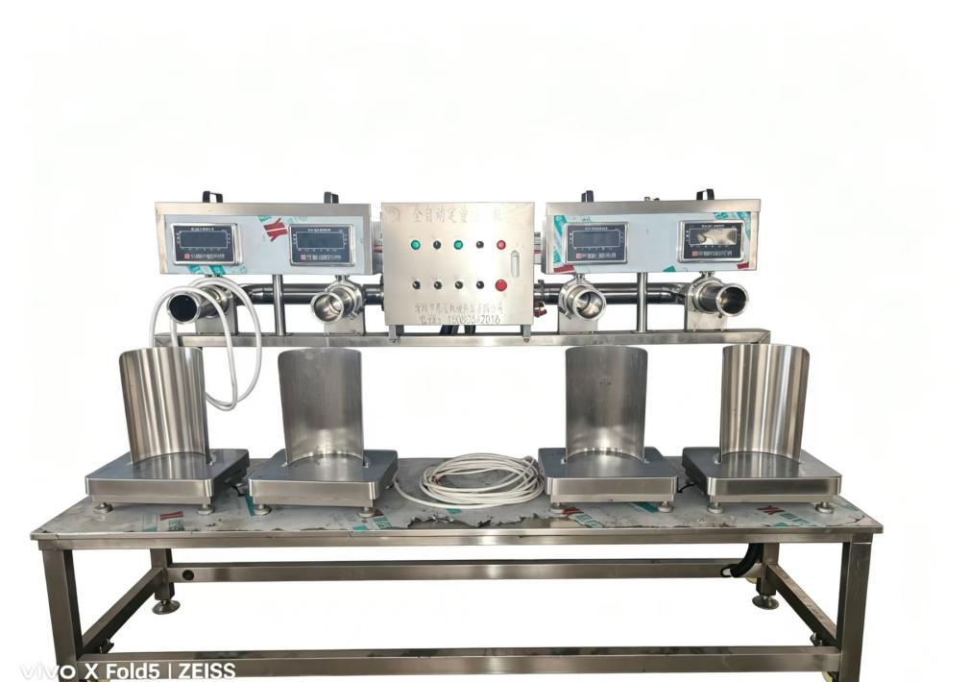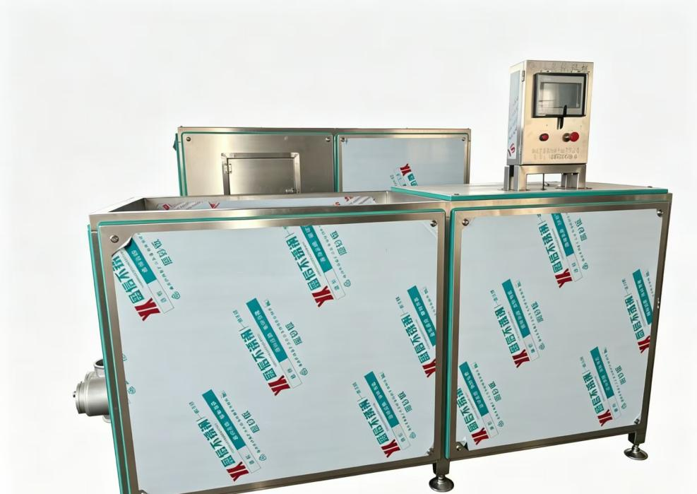

Conveying & Weighing Machine

Technical Parameters

1. Material: 304 food-grade stainless steel
2. Weighing Range: 50–2000 kg/h
3. Power: 2.2–5.5 KW
4. Voltage: 380V/50Hz (customizable)
5. Control: PLC intelligent weighing & frequency speed regulation

Features

1. Automatic feeding, real-time weighing & stable conveying.
2. High weighing precision, uniform feeding volume.
3. Compact structure, easy cleaning and linkage with production line.

Application

Online metering and conveying for meat processing, pet food full production line.

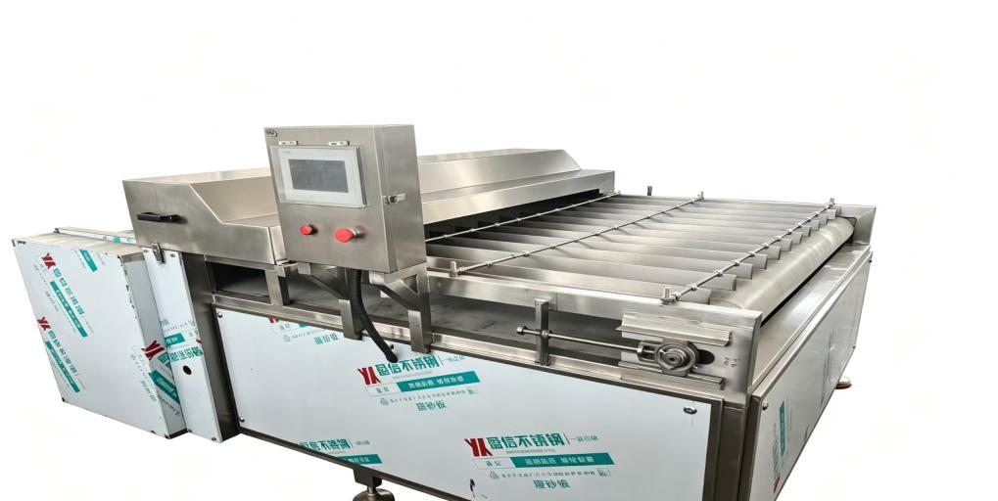Automatic Frozen Meat Block Cutting Machine

Basic Technical Parameters

1. Machine Material: Full 304 food-grade stainless steel
2. Processing Capacity: 500–3000 kg/h
3. Installed Power: 5.5–11 KW
4. Working Voltage: 380V/50Hz (customizable for global voltage)
5. Control System: PLC touch screen automatic control
6. Cutting Size: Adjustable
7. Overall Dimension: Customized according to customer demand

Product Advantages

1. PLC intelligent operation, stable running, easy parameter adjustment.
2. Food-grade stainless steel structure, clean, corrosion resistant, easy to sanitize.
3. Precise cutting with neat section, uniform material size, high efficiency.
4. Low noise, safe emergency stop design, convenient maintenance.

Application

Suitable for frozen meat, frozen chicken, frozen duck block cutting, widely used in meat processing, pet food, quick-frozen food factories.
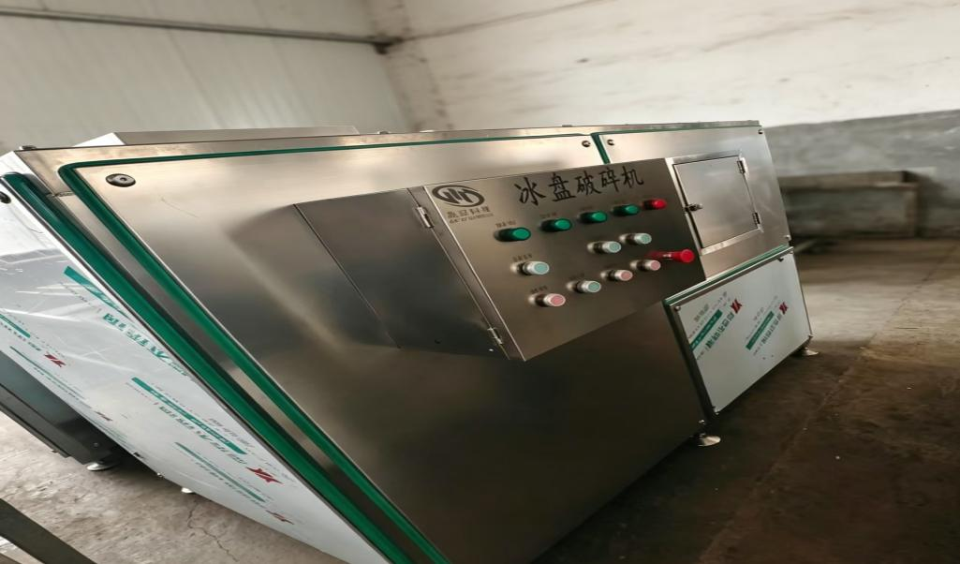
Ice Block Crusher 冰盘破碎机 英文产品参数（外贸标准版）

Basic Parameters

1. Model: Customized
2. Material: Full 304 Stainless Steel
3. Power: 7.5kw-22kw (Optional)
4. Capacity: 1–10 tons per hour
5. Voltage: 380V/50Hz (Can match overseas local voltage)
6. Dimension: Customized as output requirement
7. Working Method: Automatic feeding & crushing
8. Application: Frozen meat block crushing, frozen food pre-breaking for meat processing industry

Product Features

1. Entire machine adopts 304 stainless steel, food-grade standard, clean & corrosion-resistant.
2. Low-noise running, stable crushing, uniform particle size.
3. Full automatic button control, easy operation, safe emergency stop button equipped.
4. Wear-resistant cutter head, long service life, convenient maintenance.

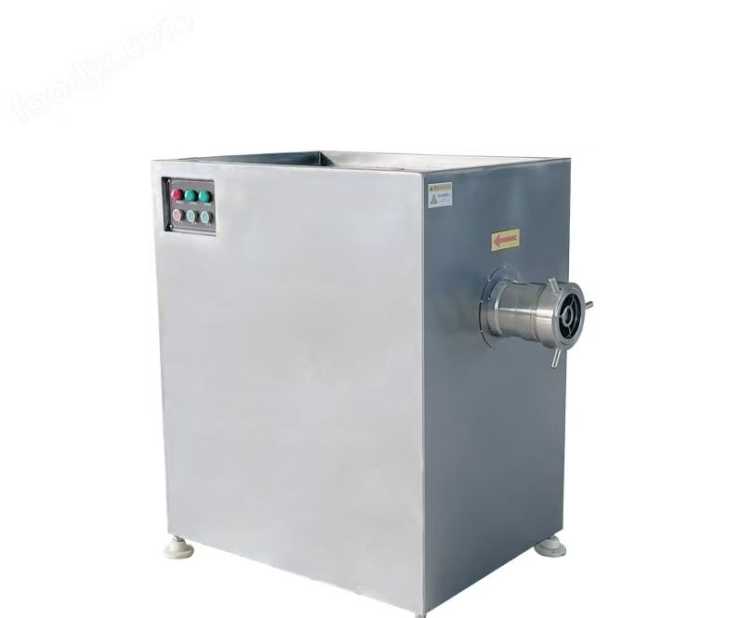Frozen Meat Grinder

Technical Parameters

1. Material: Full 304 food-grade stainless steel
2. Capacity: 500–2500 kg/h
3. Power: 7.5–22 KW
4. Voltage: 380V/50Hz (customizable for global voltage)
5. Control: Button automatic control

Features

1. Strong cutting ability, suitable for fresh and frozen meat grinding.
2. Low-temperature processing, keep meat original taste.
3. Wear-resistant blades, stable operation, easy cleaning.

Application

For meat processing factories, pet food and quick-frozen food production.
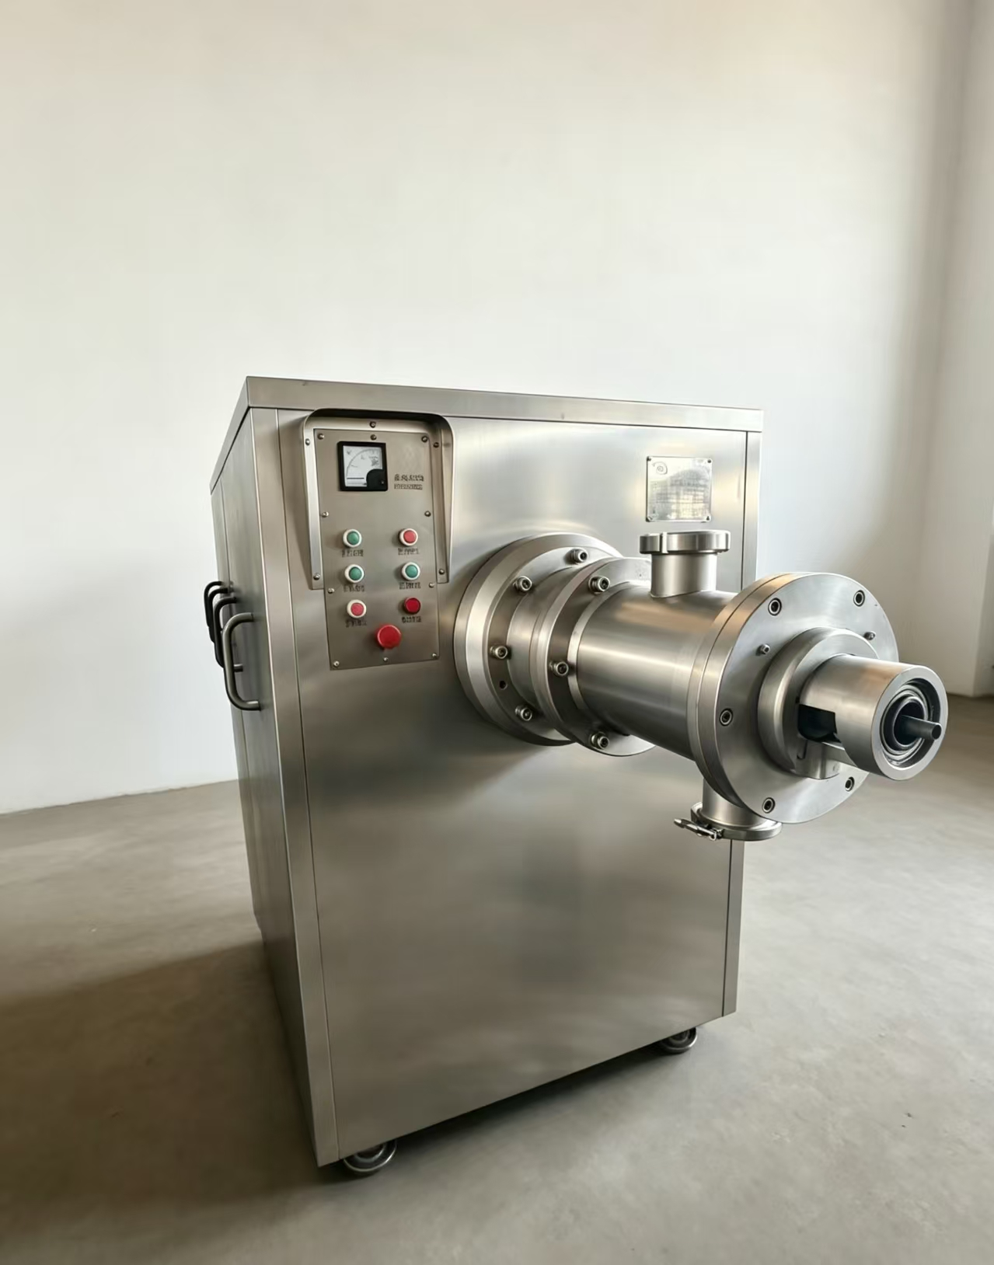

Bone & Meat Separator

Technical Parameters

1. Material: Full 304 food-grade stainless steel
2. Capacity: 500–3000 kg/h
3. Power: 7.5–22 KW
4. Voltage: 380V/50Hz (customized for global voltage)
5. Control: Button automatic control

Features

1. Low-temperature extrusion, keep meat fresh texture.
2. High meat yield, clean separation of meat and bone residue.
3. Stable operation, easy cleaning and maintenance.

Application

For poultry carcass, chicken frame, duck frame processing, widely used in meat factories and pet food production.

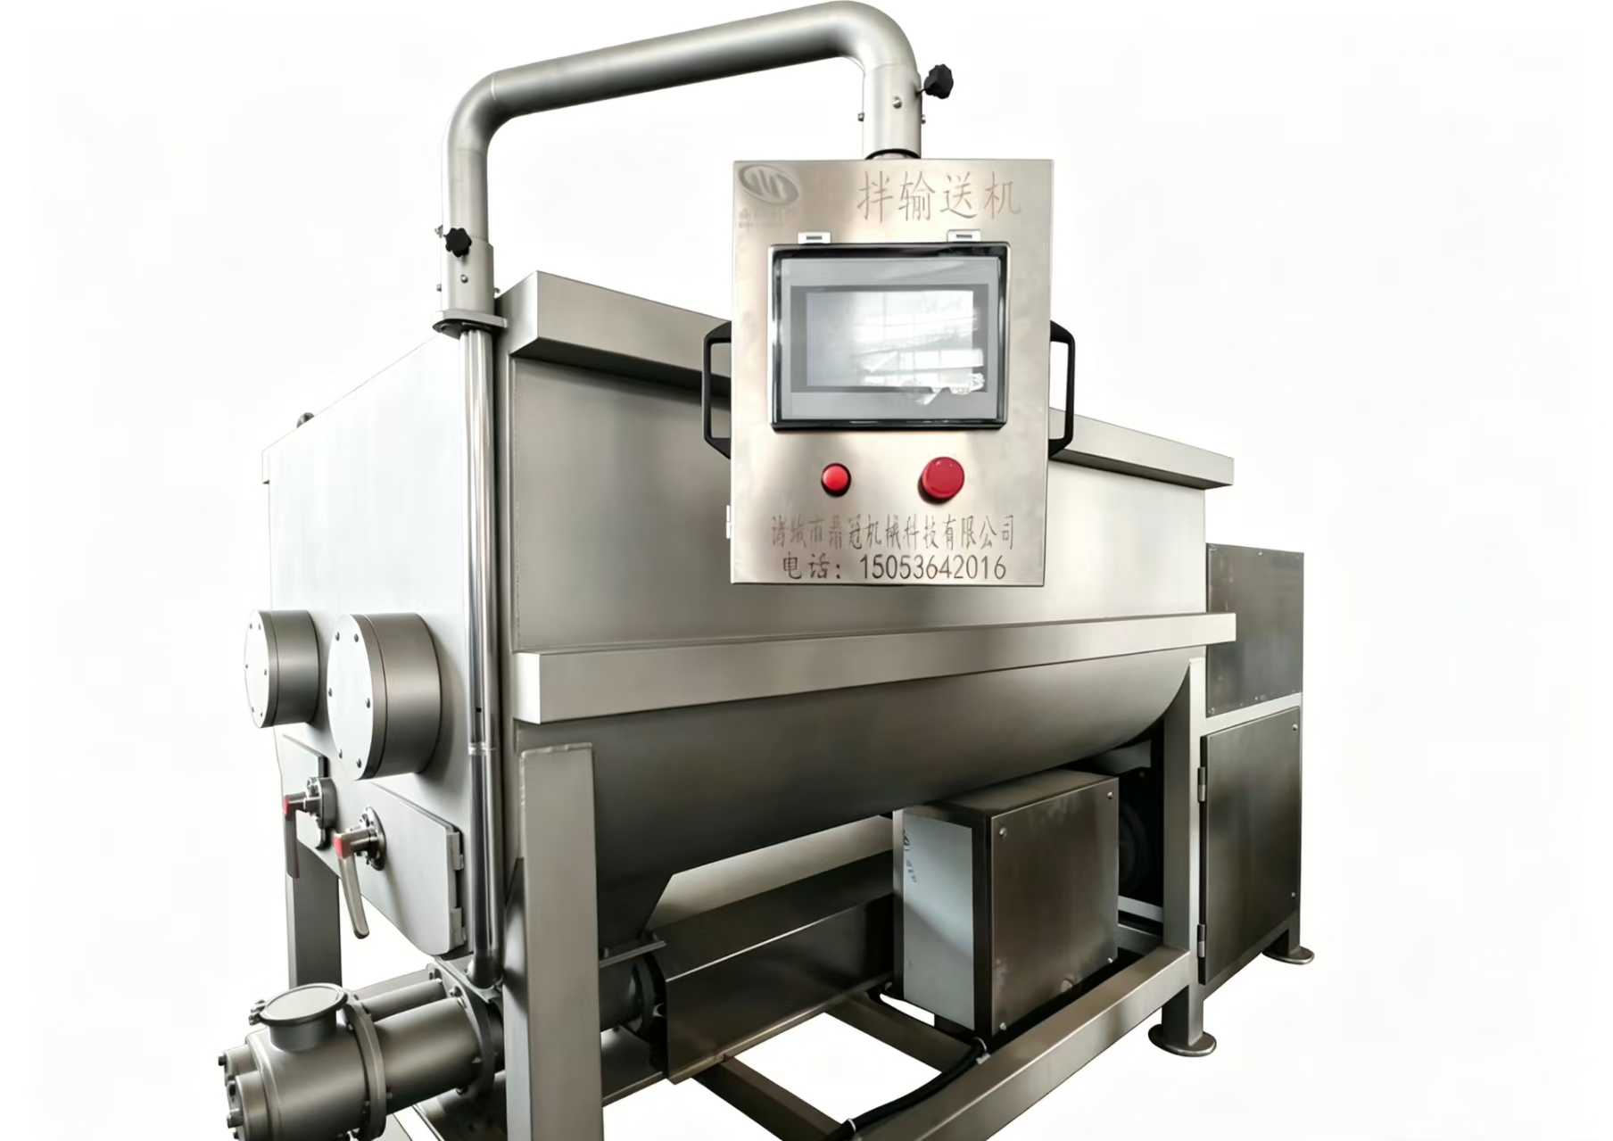
Double Shaft Meat Mixer

Technical Parameters

1. Material: Full 304 food-grade stainless steel
2. Capacity: 200–1500 kg/batch
3. Power: 5.5–15 KW
4. Voltage: 380V/50Hz (customizable)
5. Control: PLC touch screen operation

Features

1. Double-shaft stirring, uniform mixing, good raw material elasticity.
2. Closed structure, clean hygiene, easy discharging and cleaning.
3. Stable running, low noise, durable.

Application

Mixing meat paste, raw material for sausages, meat patties and pet food production lines.
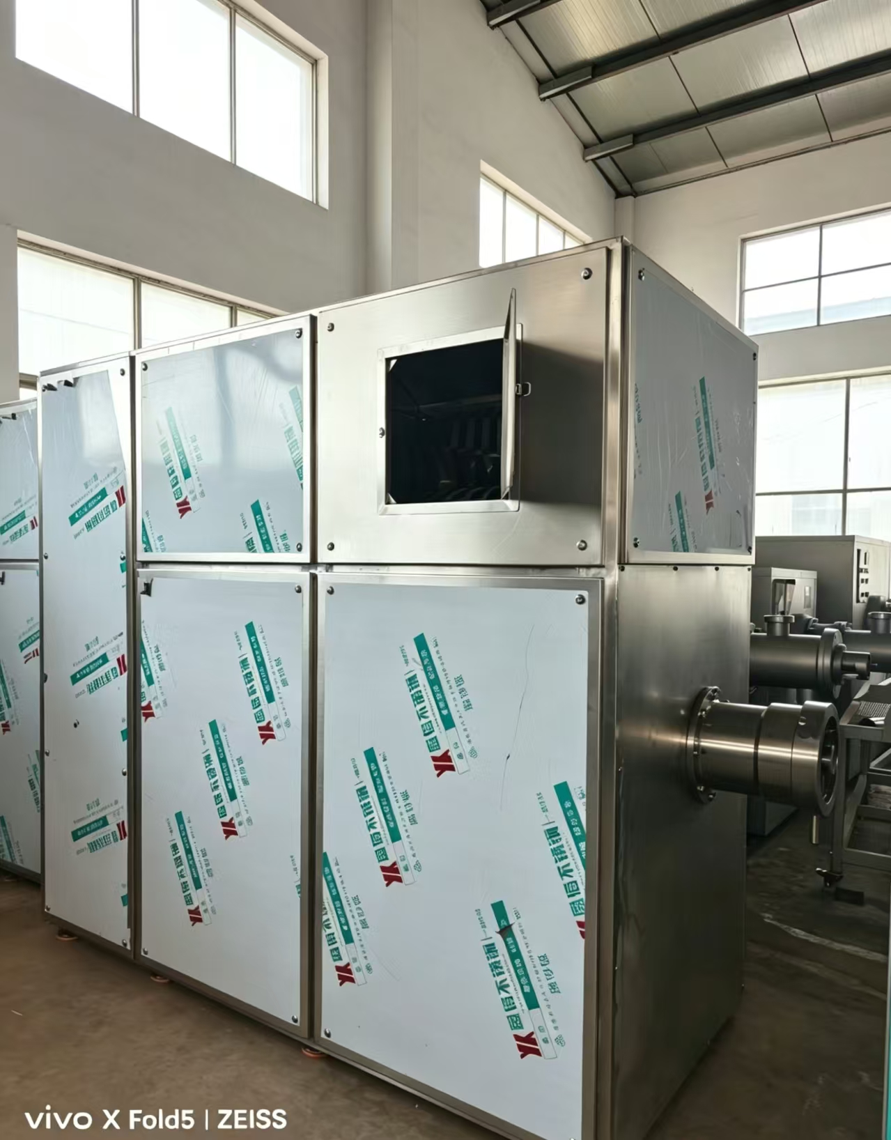

Integrated Cutting & Grinding Machine

Technical Parameters

1. Material: Full 304 food-grade stainless steel
2. Capacity: 800–3000 kg/h
3. Power: 11–30 KW
4. Voltage: 380V/50Hz (customizable)
5. Control: Button automatic control

Features

1. Integrate cutting and grinding into one machine, simplify production line.
2. Low-temperature processing, retain meat nutrition and freshness.
3. Compact structure, stable operation, easy cleaning.

Application

For frozen meat, poultry frames crushing and grinding, applied in meat processing and pet food industry.

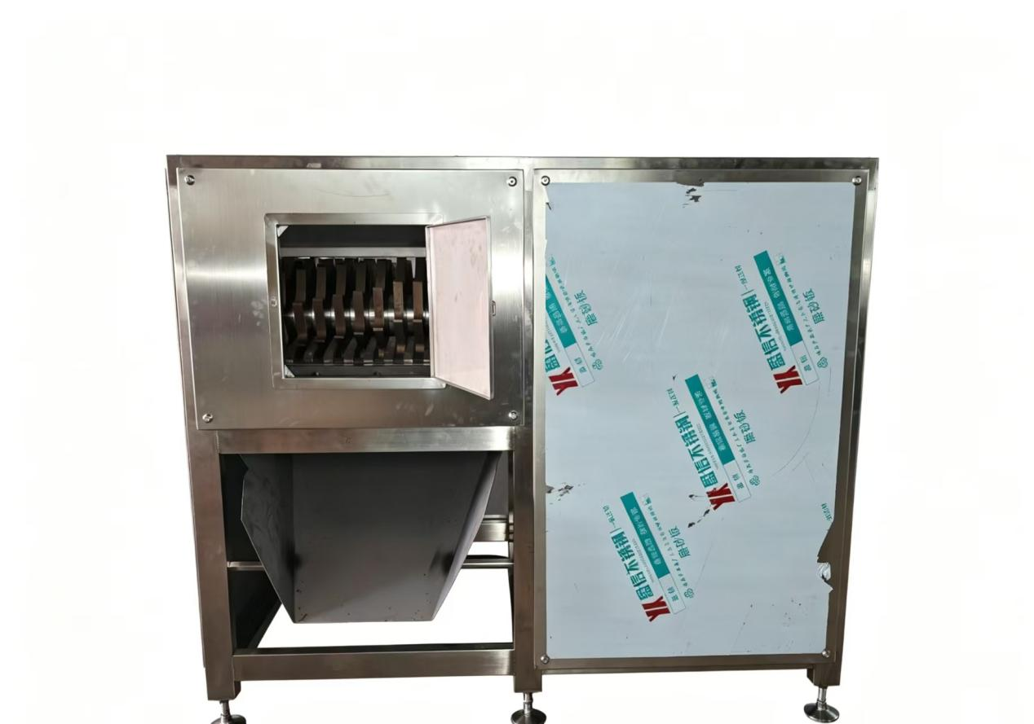

Ice Block Crusher 冰盘破碎机 英文产品参数（外贸标准版）

Basic Parameters

1. Model: Customized
2. Material: Full 304 Stainless Steel
3. Power: 7.5kw-22kw (Optional)
4. Capacity: 1–10 tons per hour
5. Voltage: 380V/50Hz (Can match overseas local voltage)
6. Dimension: Customized as output requirement
7. Working Method: Automatic feeding & crushing
8. Application: Frozen meat block crushing, frozen food pre-breaking for meat processing industry

Product Features

1. Entire machine adopts 304 stainless steel, food-grade standard, clean & corrosion-resistant.
2. Low-noise running, stable crushing, uniform particle size.
3. Full automatic button control, easy operation, safe emergency stop button equipped.
4. Wear-resistant cutter head, long service life, convenient maintenance.

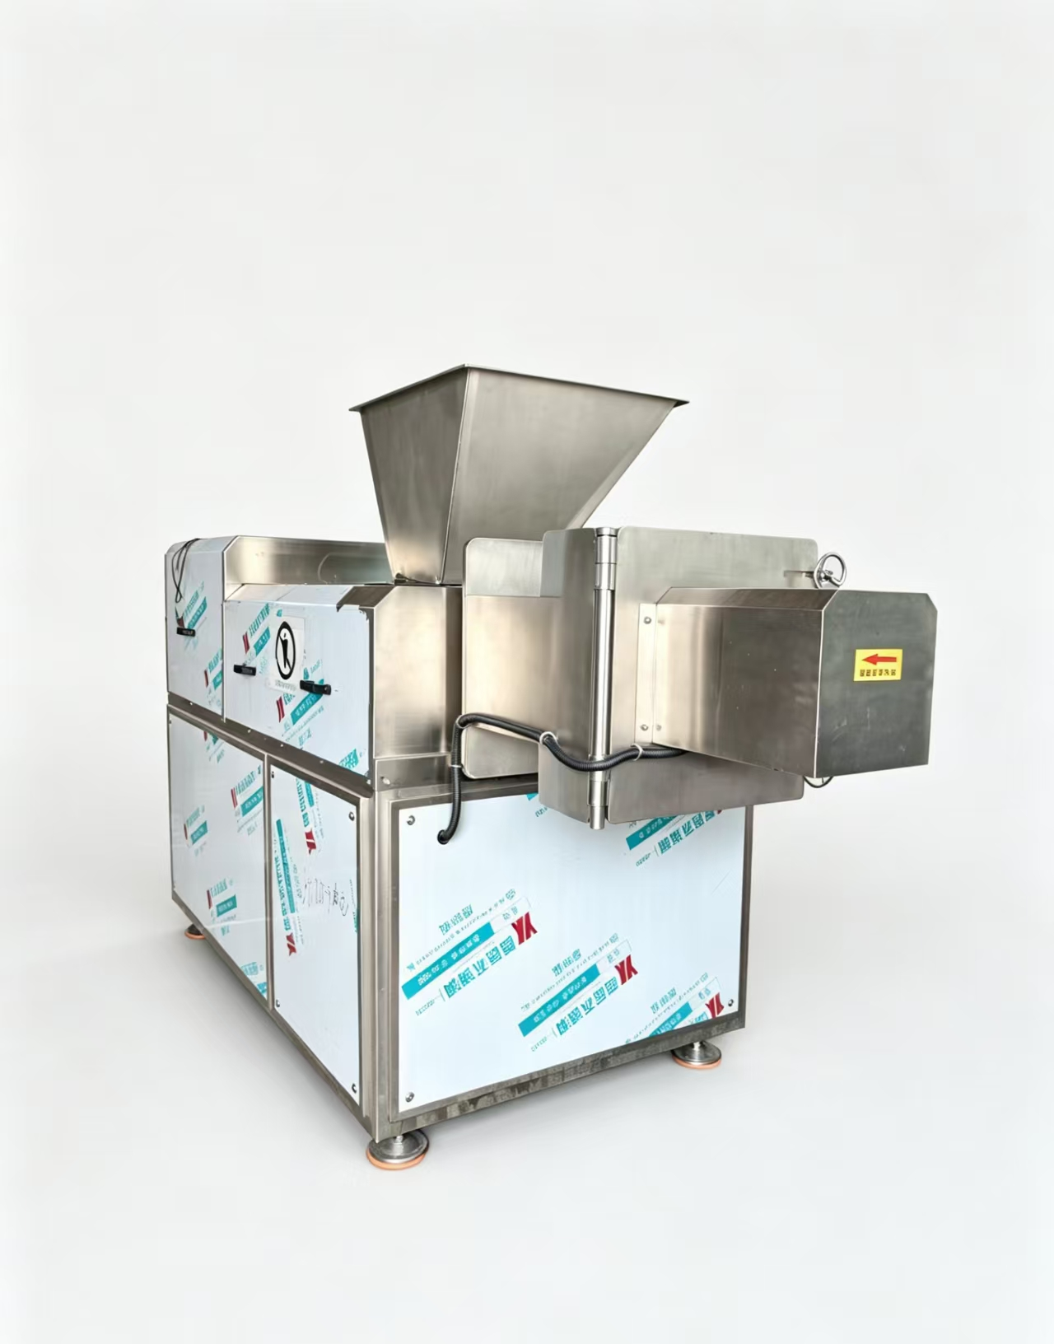Granule Extruder

Technical Parameters

1. Material: Full 304 food-grade stainless steel
2. Output Capacity: 400–2500 kg/h
3. Installed Power: 7.5–18.5 KW
4. Working Voltage: 380V/50Hz (customizable for global voltage)
5. Control Mode: Automatic button control

Product Advantages

1. Even extrusion molding, uniform granule size.
2. Low-temperature processing, maintain raw material freshness.
3. Stable operation, easy disassembly and cleaning.

Application

Suitable for pet food, meat pellet, feed granule forming in meat deep processing production line.
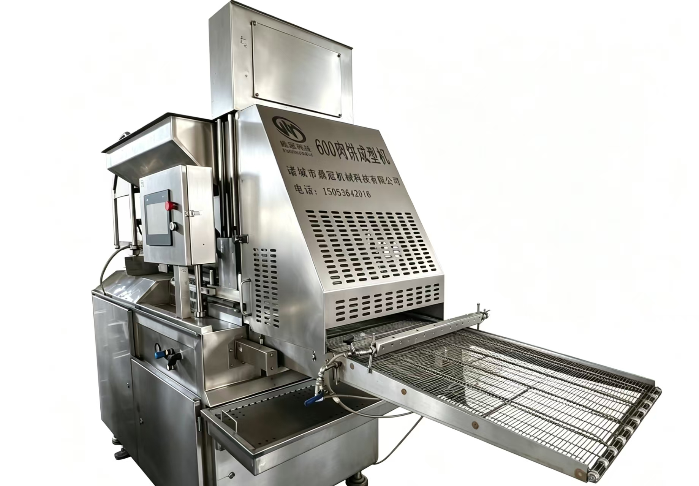
Meat Patty Forming Machine Model 600

Technical Parameters

1. Material: Full 304 food-grade stainless steel
2. Capacity: 600 kg/h
3. Power: 4.5 KW
4. Voltage: 380V/50Hz (customizable)
5. Control: PLC touch screen automatic control
6. Product shape & weight: adjustable

Features

1. High forming rate, neat patty shape, uniform weight.
2. Stable operation, easy mold replacement and cleaning.
3. Low noise, compact structure, save workshop space.

Application

For meat patty, chicken nugget, burger patty forming, used in meat processing and quick-frozen food factories.

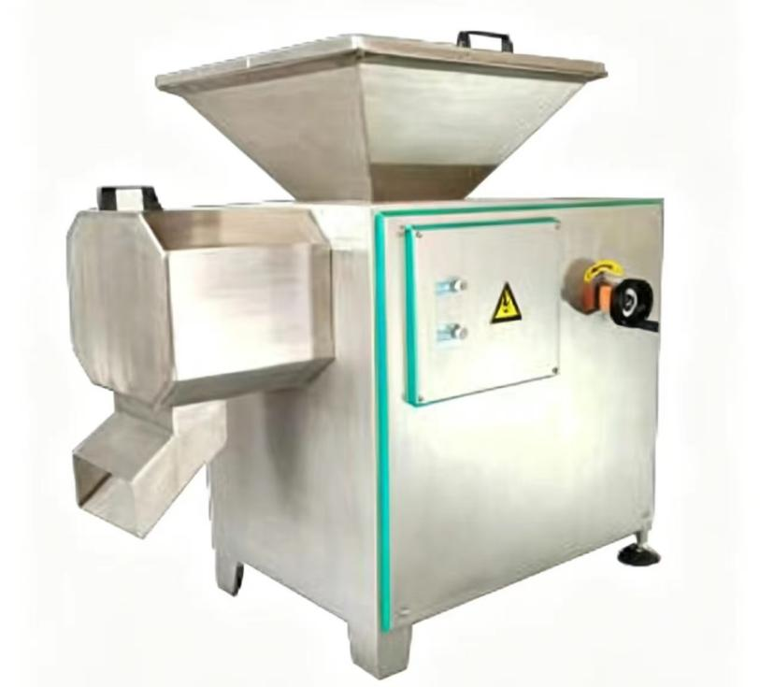

Meat Powder Grinder

Technical Parameters

1. Material: Full 304 food-grade stainless steel
2. Capacity: 400–2000 kg/h
3. Power: 7.5–18.5 KW
4. Voltage: 380V/50Hz (customizable for global voltage)
5. Control: Button automatic control

Product Features

1. Fine crushing, uniform powder fineness, adjustable particle size.
2. Low-temperature processing, keep raw material nutrition intact.
3. Wear-resistant cutter group, stable running, easy disassembly for cleaning.

Application

Used for fine grinding of meat material in pet food and meat deep-processing production lines.

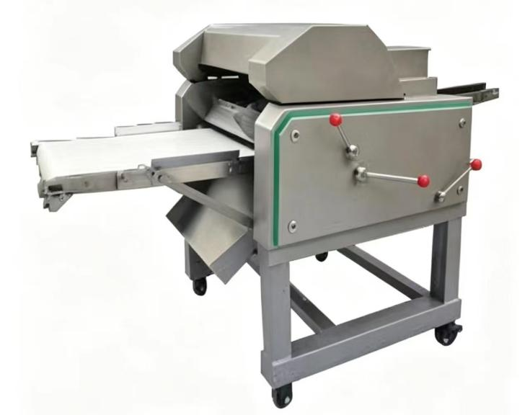
Meat Skin Peeling Machine

Technical Parameters

1. Material: Full 304 food-grade stainless steel
2. Processing Capacity: 400–2000 kg/h
3. Installed Power: 3.0–7.5 KW
4. Working Voltage: 380V/50Hz (global voltage customizable)
5. Adjustment: Manual thickness adjustment

Product Advantages

1. High peeling efficiency, low meat loss rate.
2. Clear peeling, uniform thickness, easy parameter adjustment.
3. Equipped with moving casters, flexible placement, easy disassembly & cleaning.

Application

Used for poultry meat, chicken & duck raw material skin removing, for meat processing factories and pet food production lines.
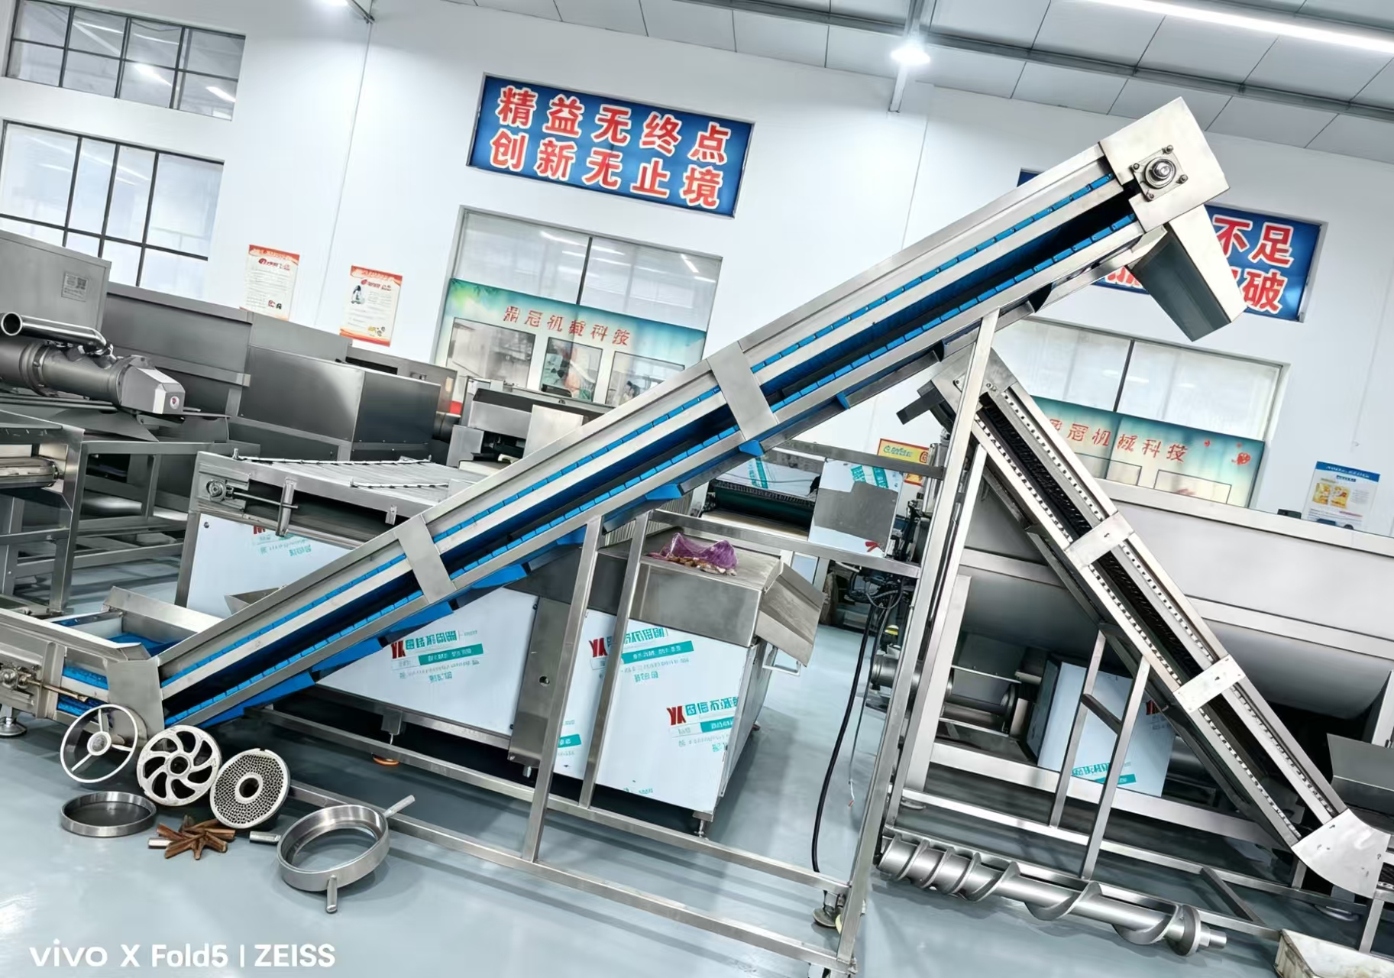
Inclined Belt Elevator

Technical Parameters

1. Material: Frame 304 stainless steel, food-grade belt
2. Conveying Capacity: 500–3000 kg/h
3. Power: 1.5–3 KW
4. Voltage: 380V/50Hz (customizable for overseas)
5. Speed: Frequency adjustable

Features

1. Stable material lifting, anti-slip belt design.
2. Fully stainless steel, clean and easy to wash.
3. Flexible height matching, perfect for production line connection.

Application

Material feeding transportation for meat processing & pet food production line.

